Jen Shin

29 January 2018

402 HW #1

* 1. All software engineering projects must have a plan that shows what the members are supposed to be doing, when and how they should do it, and what project goals are. The planning involves figuring out the requirements, high-level design, low-level design. After that the programmers can move on to development and testing.
  2. Requirement gathering revolves around what the customer wants and needs. High-level design includes deciding platform, database, classes, user interfaces, and external interfaces. Low-level design is the breakdown of the high-level design and includes information about how the pieces should work together. Development will be writing code and testing will be running through the code for bugs and to guarantee that the program works properly as intended.

2.5 JBGE stands for just barely good enough and the idea is that writing too much documentation will waste too much time of the programmer because it will need constant revision and update as the code is changed.

3.2 All the possible paths include:

A, D, E, M, Q = 5 + 6 + 7 + 9 + 4 = 31

A, O, N, R = 5 + 5 + 15 + 4 = 29

C, B, M, Q = 4 + 5 + 9 + 4 = 22

C, B, N, R = 4 + 5 + 15 + 4 = 28

C, L, Q/R or K = 4 + 6 + 4 or 5 = 18 or 19

F = 7

G, L, K, Q/R = 6 + 6 + 5 + 4 = 21

G, D, E, M, Q/R = 6 + 6 + 7 + 9 + 4 = 32

G, O, N, R = 6 + 5 + 15 + 4 = 30

G, O, P = 6 + 5 + 6 = 17

H, I, M, Q = 3 + 3 + 9 + 4 = 19

H, J, O, N, R = 3 + 3 + 5 + 15 + 4 = 30

H, J, N, R = 3 + 3 + 15 + 4 = 25

The Critical path includes G Rendering engine, D Character editor, E Character animator, M Character library, and Q Character testing. This adds up to 32 total days.

3.4 Weekends are mostly not included since we do not work on weekends. Gray color means non work days including weekends and holidays. (two versions included: with / without arrow)

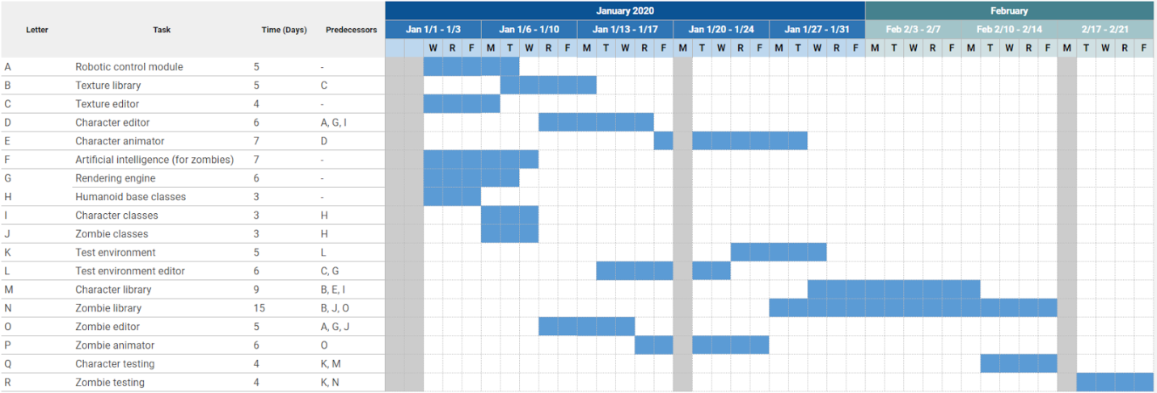

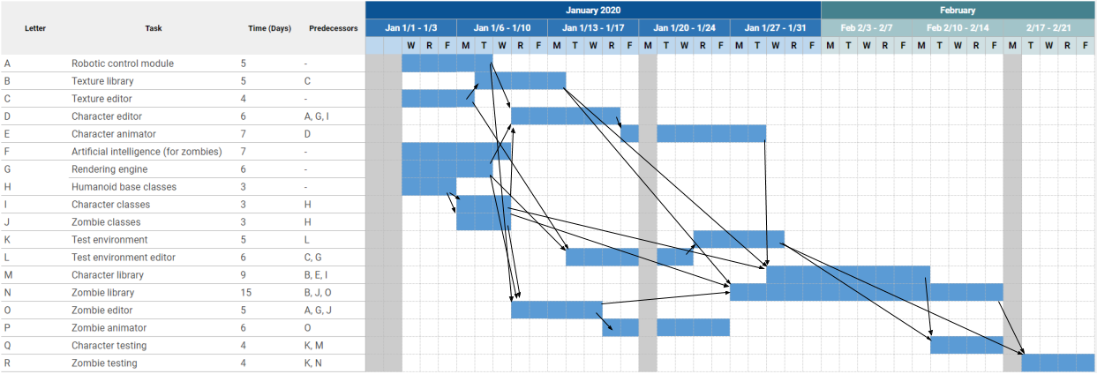

3.6 Unexpected problems such as workers getting ill or missing work days can be planned by expanding each task’s time estimate by some amount in order to have some padding within the schedules. Adding specific tasks to the project to represent lost time, allocating sick days beforehand, would help too. Lost time due to order being late or waiting for approval can be dealt by carefully planning for approvals, order lead times, and set up.

3.8 The first biggest mistake you can make is to ignore the problem and assume that it can be made up later and the second would be assuming that adding extra developers will reduce the time needed to finish the task.

4.1 Five characteristics of good requirements are clear, unambiguous, consistent, prioritized, and verifiable.

4.3 a. Allow users to monitor uploads/downloads while away from the office. – Business

b. Let the user specify website log-in parameters such as an Internet address, a port, a username, and a password. – User

c. Let the user specify upload/download parameters such as number of retries if there's a problem. – User

d. Let the user select an Internet location, a local file, and a time to perform the upload/download. – User

e. Let the user schedule uploads/downloads at any time. – User

f. Allow uploads/downloads to run at any time. – Nonfunctional

g. Make uploads/downloads transfer at least 8 Mbps. – Nonfunctional

h. Run uploads/downloads sequentially. Two cannot run at the same time. – Implementation

i. If an upload/download is scheduled for a time when another is in progress, it waits until the other one finishes. – Implementation

j. Perform schedule uploads/downloads. – Functional

k. Keep a log of all attempted uploads/downloads and whether the succeeded. – Functional

l. Let the user empty the log. – User

m. Display reports of upoad/download attempts. – Functional

n. Let the user view the log reports on a remote device such as a phone. – Implementation

o. Send an e-mail to an administrator if an upload/download fails more than its maximum retry number of times. – Functional

p. Send a text message to an administrator if an upload/download fails more than its maximum retry number of times. – Functional

There were requirements in each category.

4.9 Must: Exit, Sort words in category and allow the users to choose the category, Display category, Display space or dash if it exists.

Should: Hint, Music, Sound Effects, Better graphical representation, Use different colors, Show how many times user can get wrong, how many times user got wrong.

Could: Play together (multi-user) system, Friend list, Vertical layout

Won’t: In different Language, iPhone release.